Week 2 - Question

8743075

Joao Palma

**Where would you position the waypoints for each guard to create the best gameplay?**

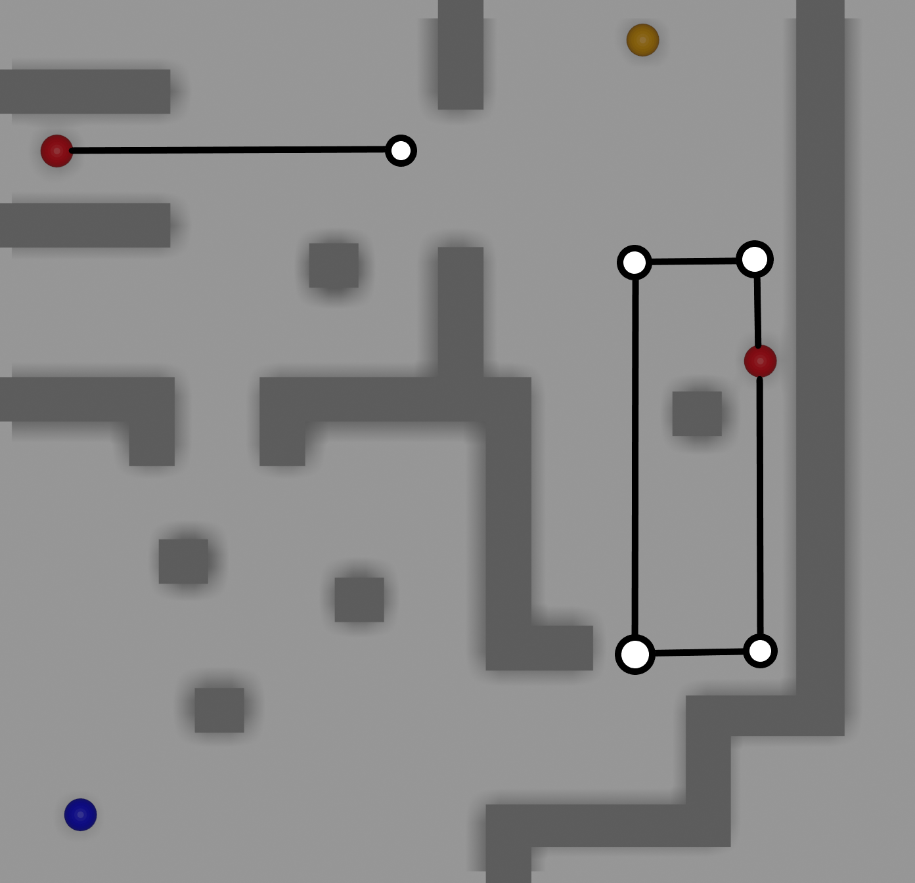

These are the paths that I would personally pick. I took the routes into consideration, having the longer one being the easiest and the top left the hardest.

I wanted to make the level somewhat difficult but rewarding in some areas and not so much in others, thus creating some balance in terms of gameplay.

When I thought of these paths I took speed running into consideration as well and that is why the paths are so funny looking but simple.

To explain how this pathing would work here are some examples:

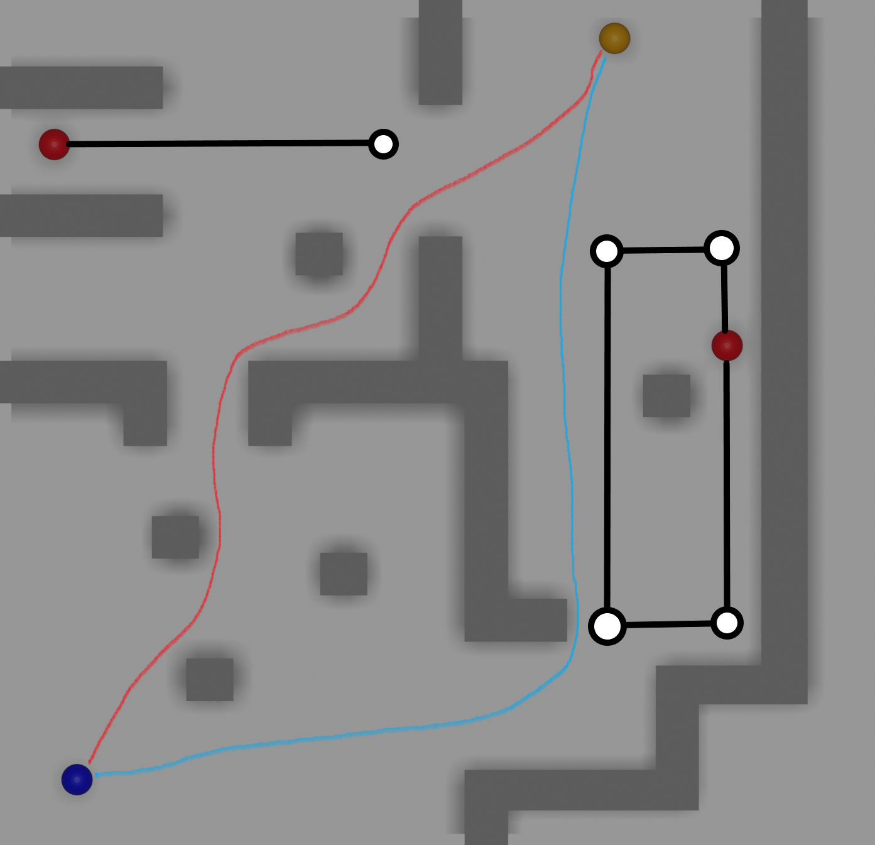

The top left being the shortest and quickest path to the treasure it would only make sense to increase its difficulty, having the guard making a shorter thus quicker path helps achieve the wanted challenge. This also allows the guard to cover for the other one when their routes don’t coincide.

The bottom right has the longest way around for maybe newer players, being the easiest path, this way does shove off a lot more time, where in a speed run would not be beneficial.

With all this said I think these would be optimal path for a level of this scale and difficulty and over doing it would make it too hard.

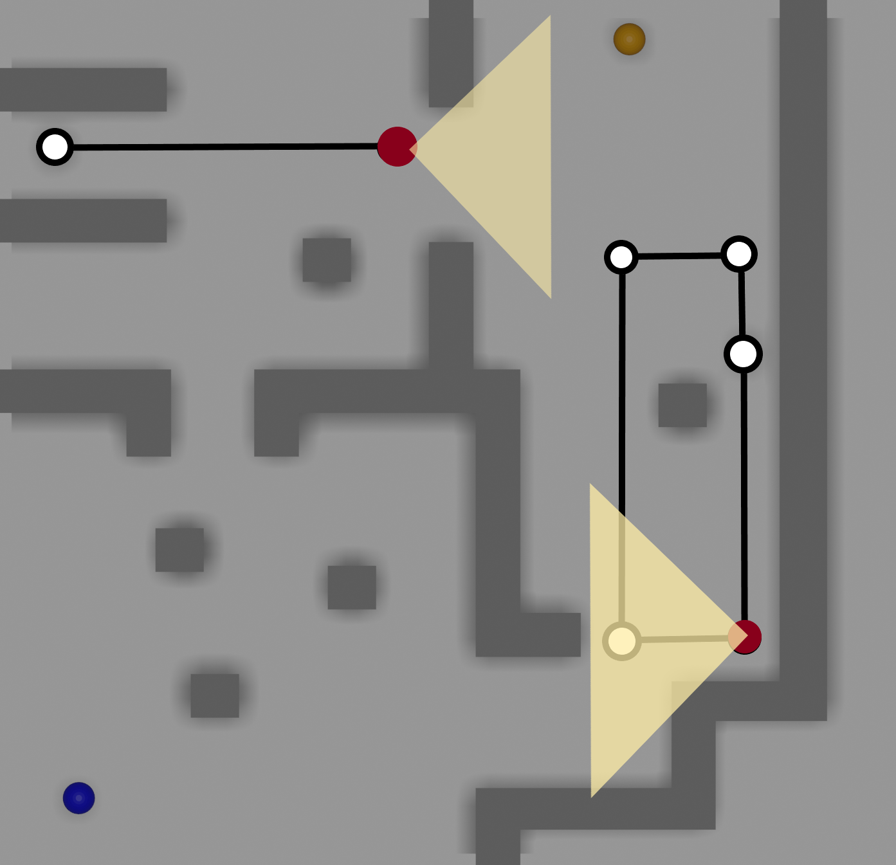

To give some context on the guards routes and their vision range I added visual aids, and as you can see, these cover a good portion of where the player would go through, what I really liked about the paths I chose is the fact that both guards at one time will be covering for their blind spots, onec again not making the level too easy and having the player thinking better and time his route to achieve the goal.

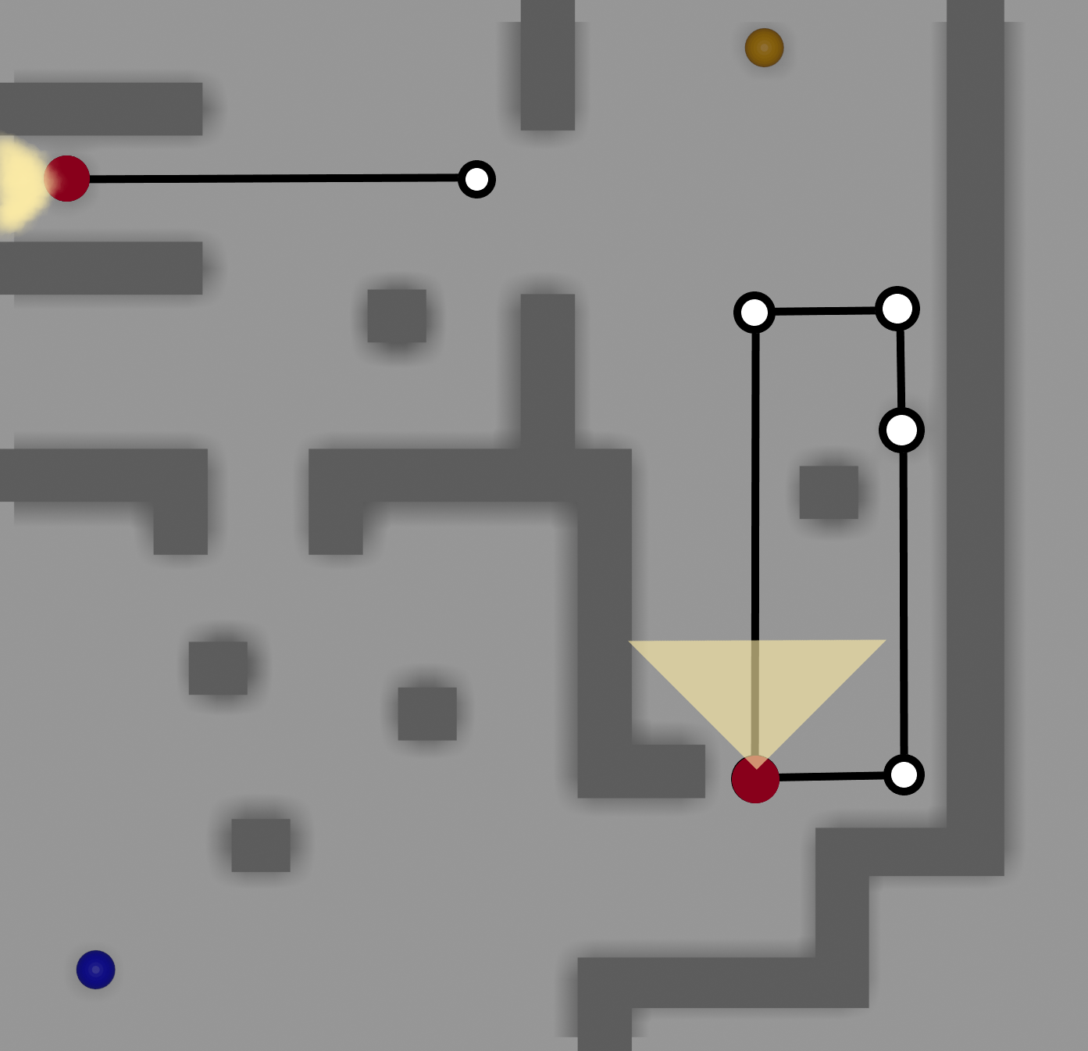

As the top left guard goes back, the top path becomes “open” to traverse, but as you can see, as soon as the player is reaching the final entry point to the treasure, the other guard is coming straight up to potentially catch the player.

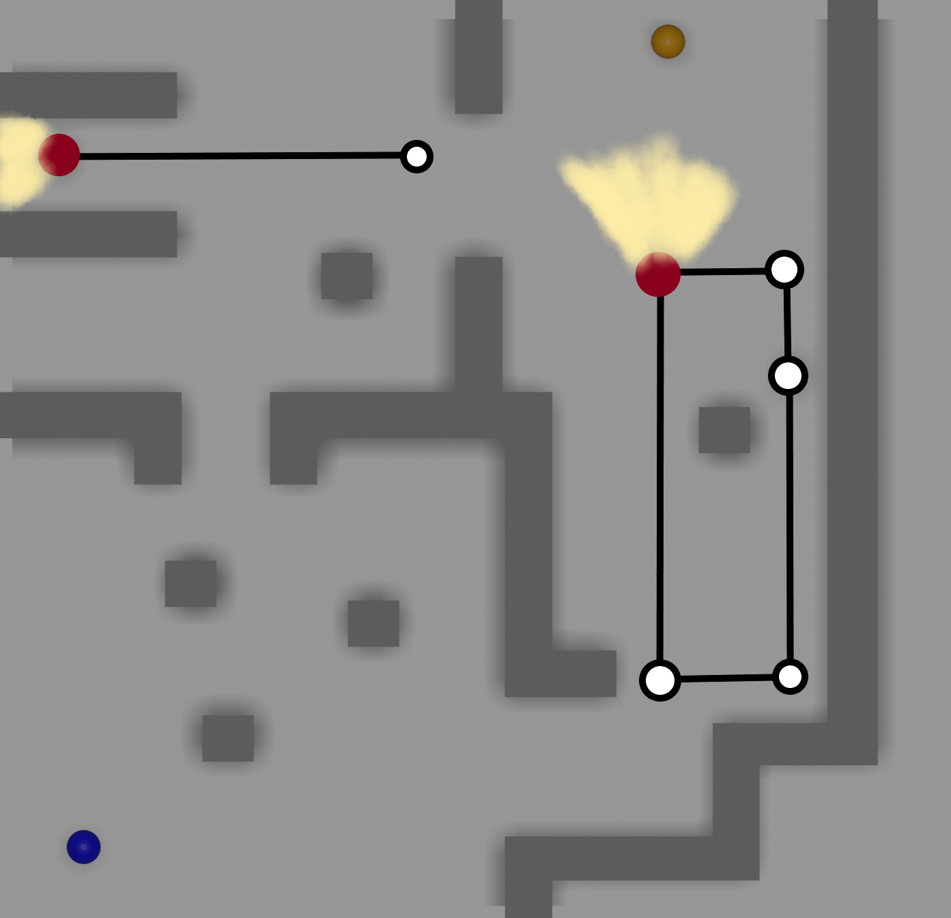

The same applies for when the player chooses to go the long way around, while the guard on the right would lose vision from the player he would be free to go straight to the treasure, but since the top left guard path is much smaller, making faster path rotations, the treasure is always somewhat guarded.